**Module 3 Lab 2: Integrating MongoDB with Express.js**

Naga Sindhuri Munjila

Dinesh Sthapit

18th February, 2024

**Module 3 Lab 2: Integrating MongoDB with Express.js**

Express.js server code in app.js and the browser displaying "Hello World!".

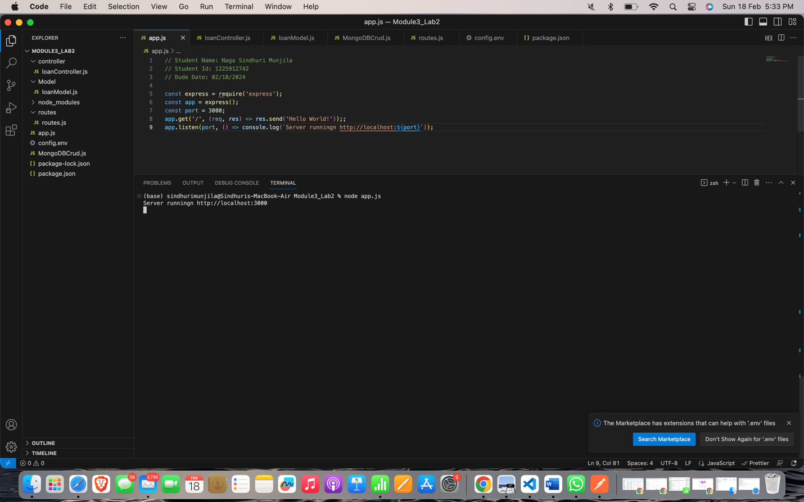

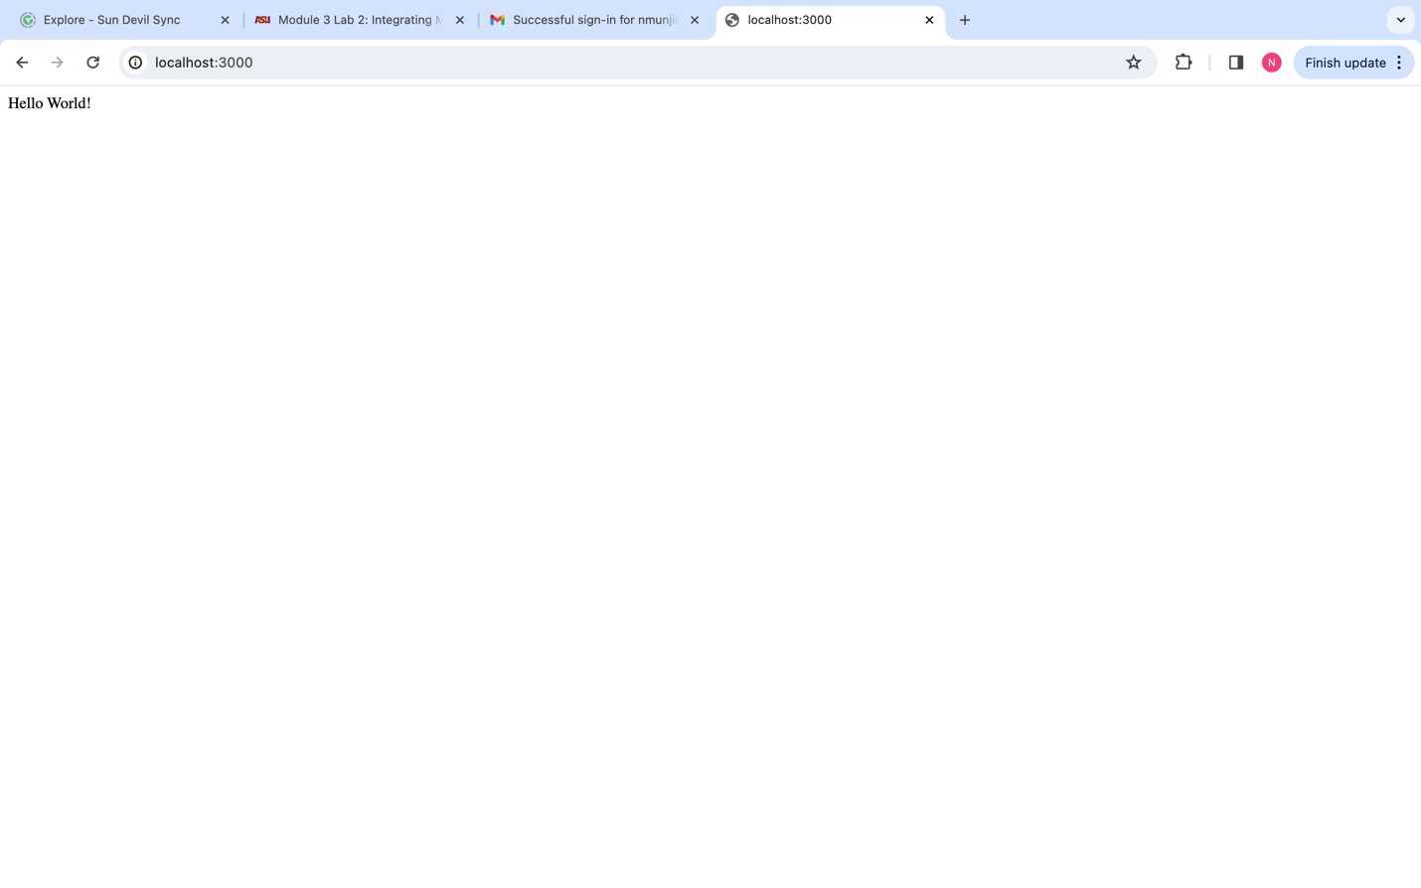

Routing code in Express.js, showing the CRUD operation routes.

Router.js

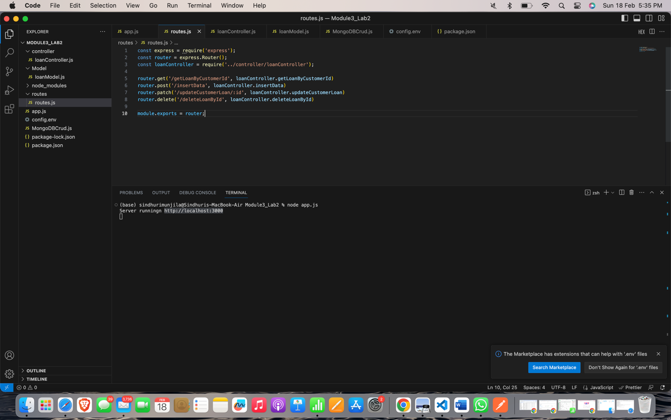

Controller.js

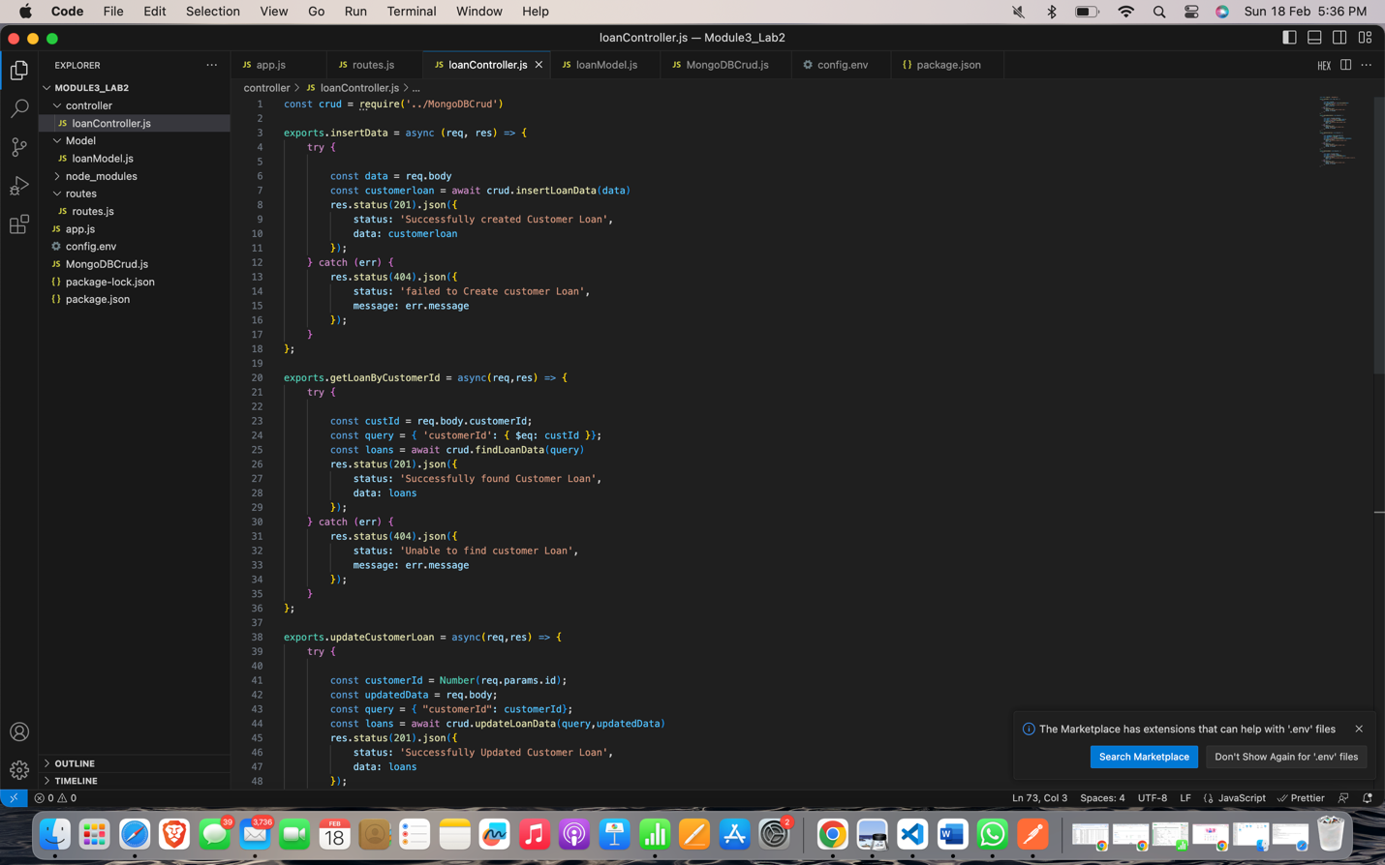

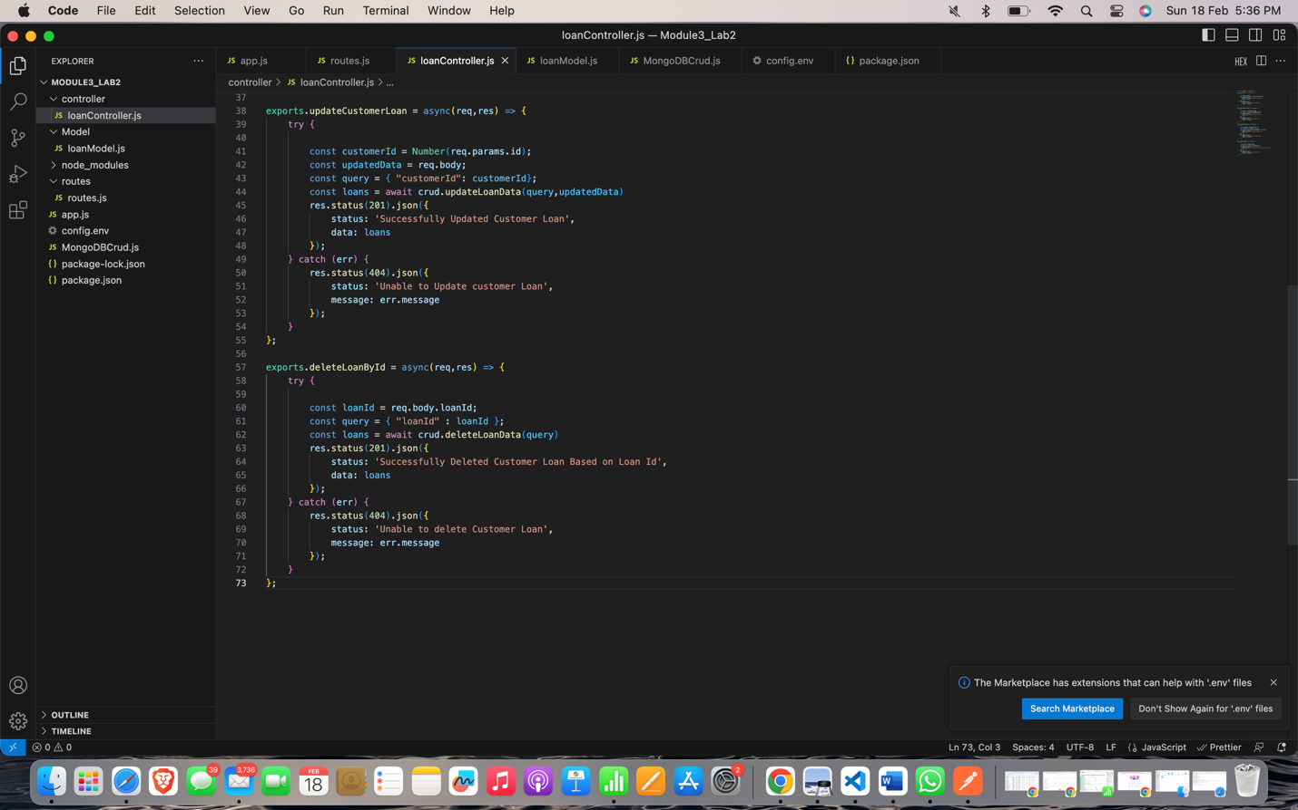

app.js

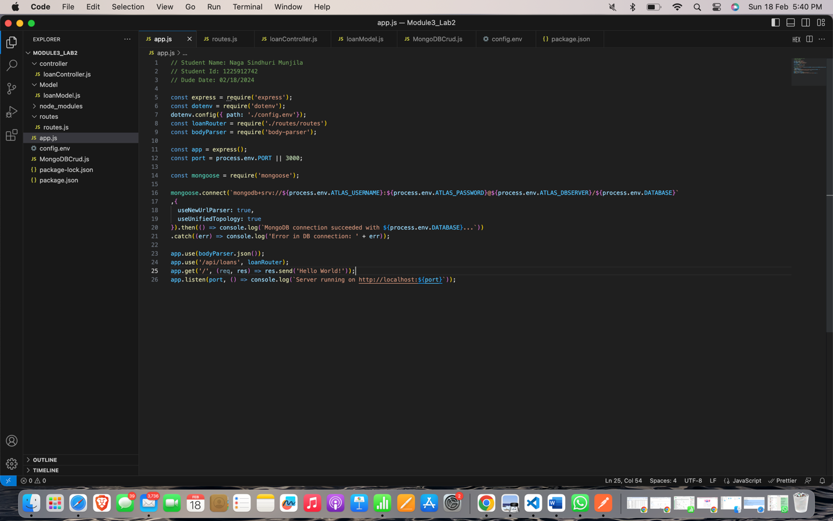

Screenshots from Postman which displays API responses and requests, debugging process in VSCode.

Insert:

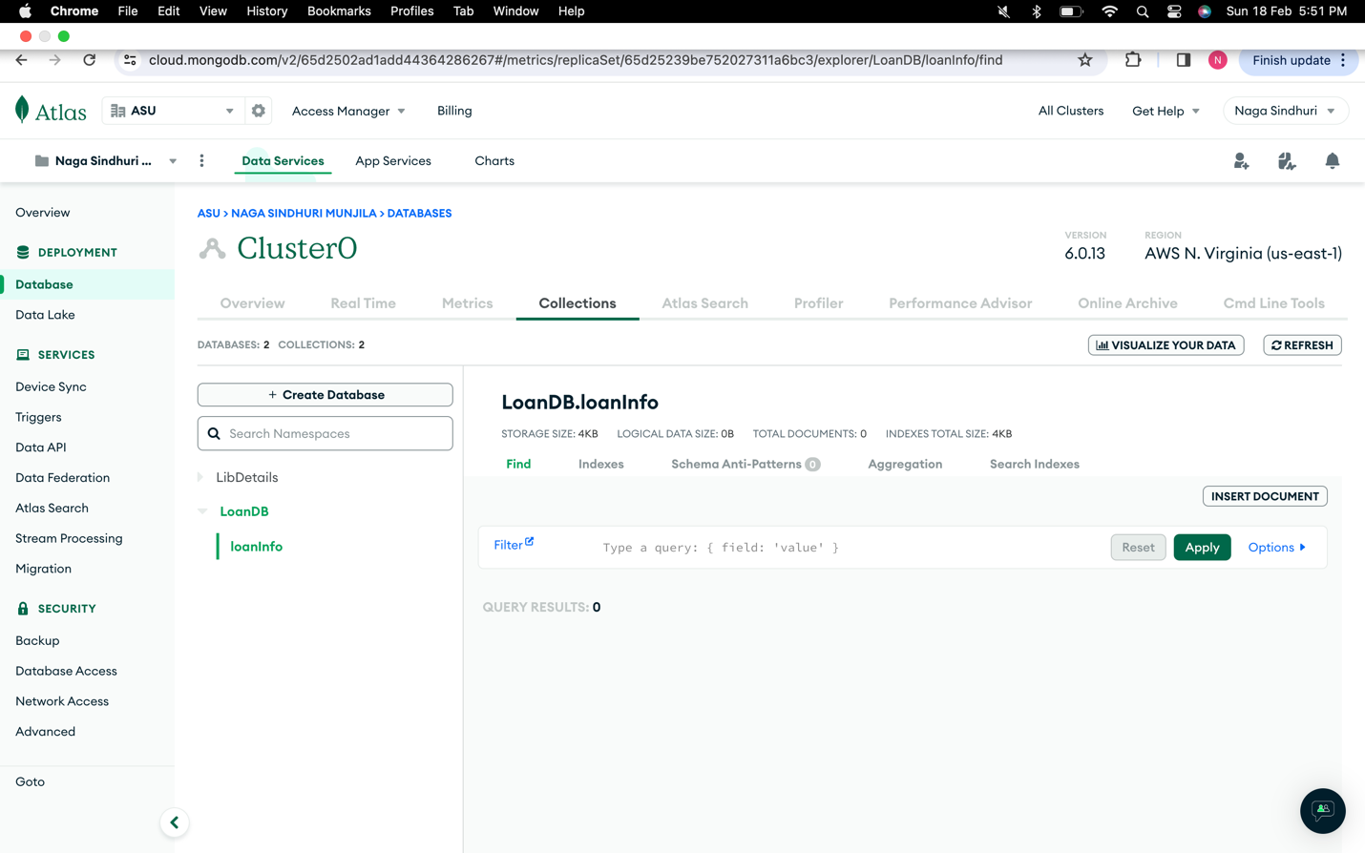

The screenshot provided above shows that there are no records in the database (Mongo Atlas).

Postman API call:

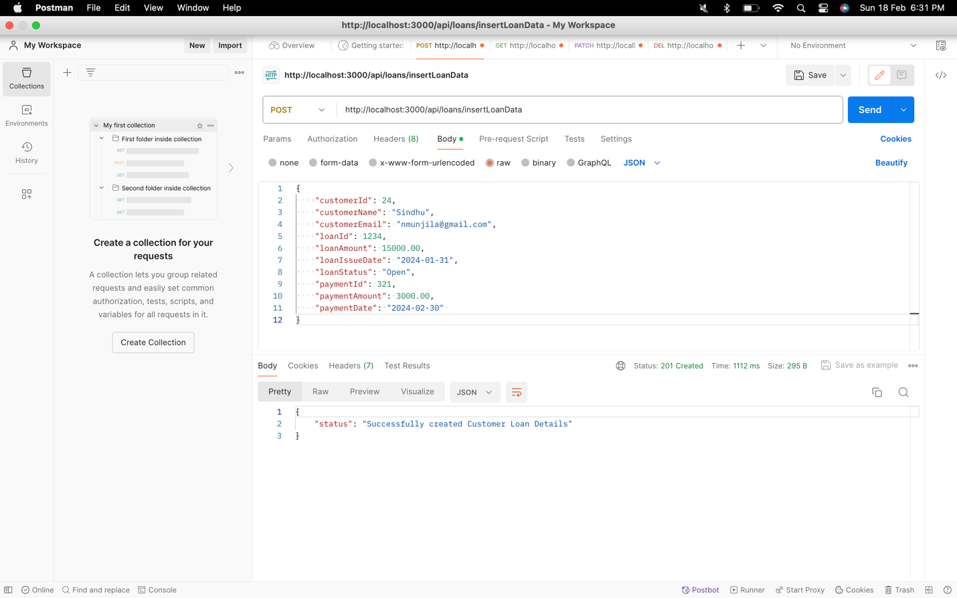

Terminal:

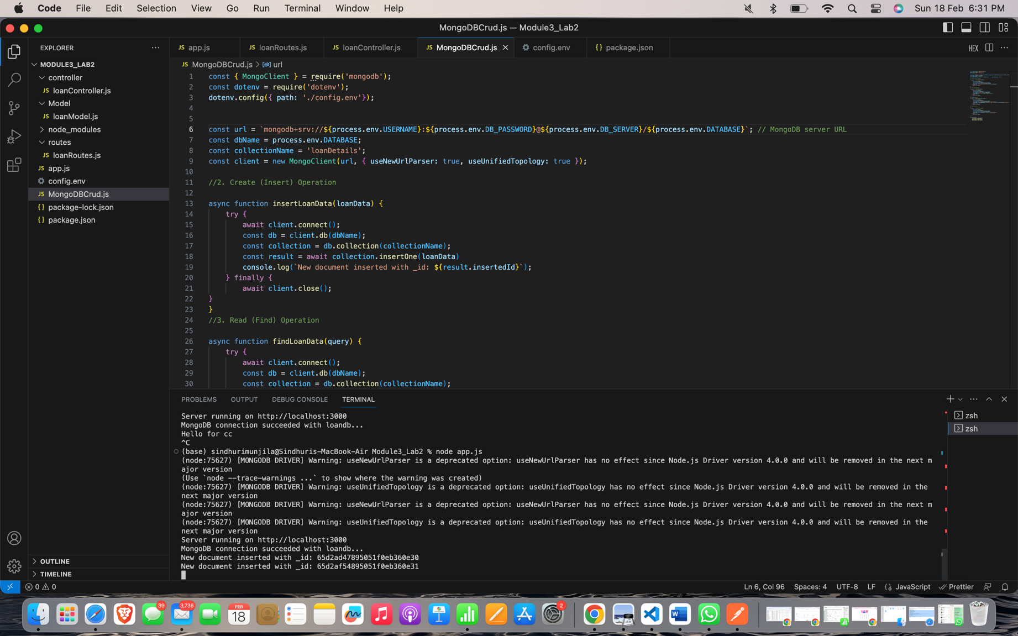

Atlas:

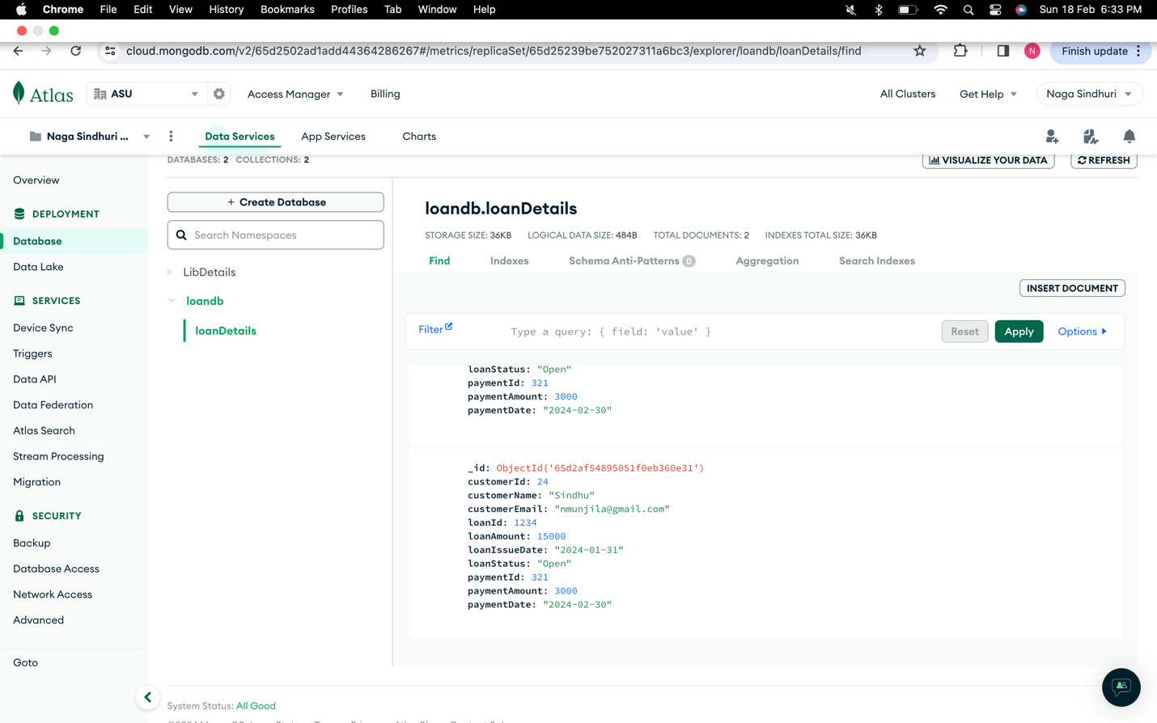

Find Command:

Postman:

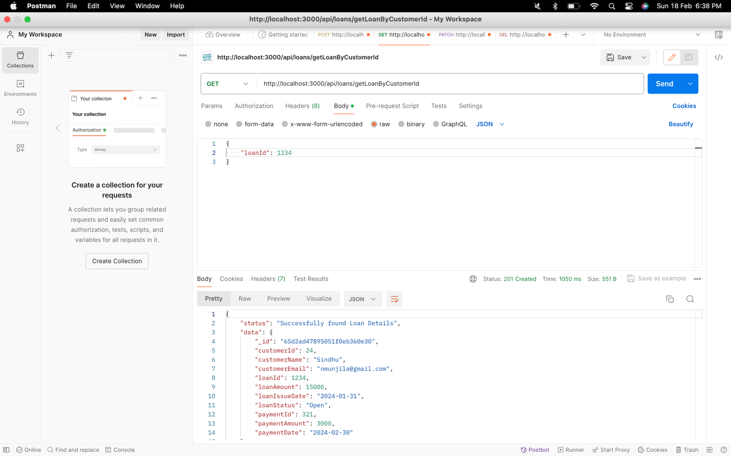

Terminal:

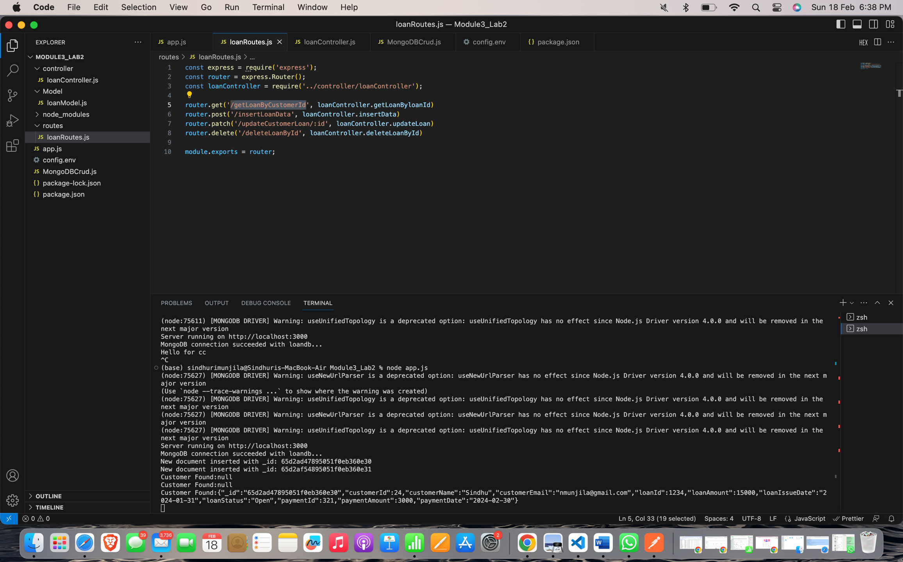

Atlas:

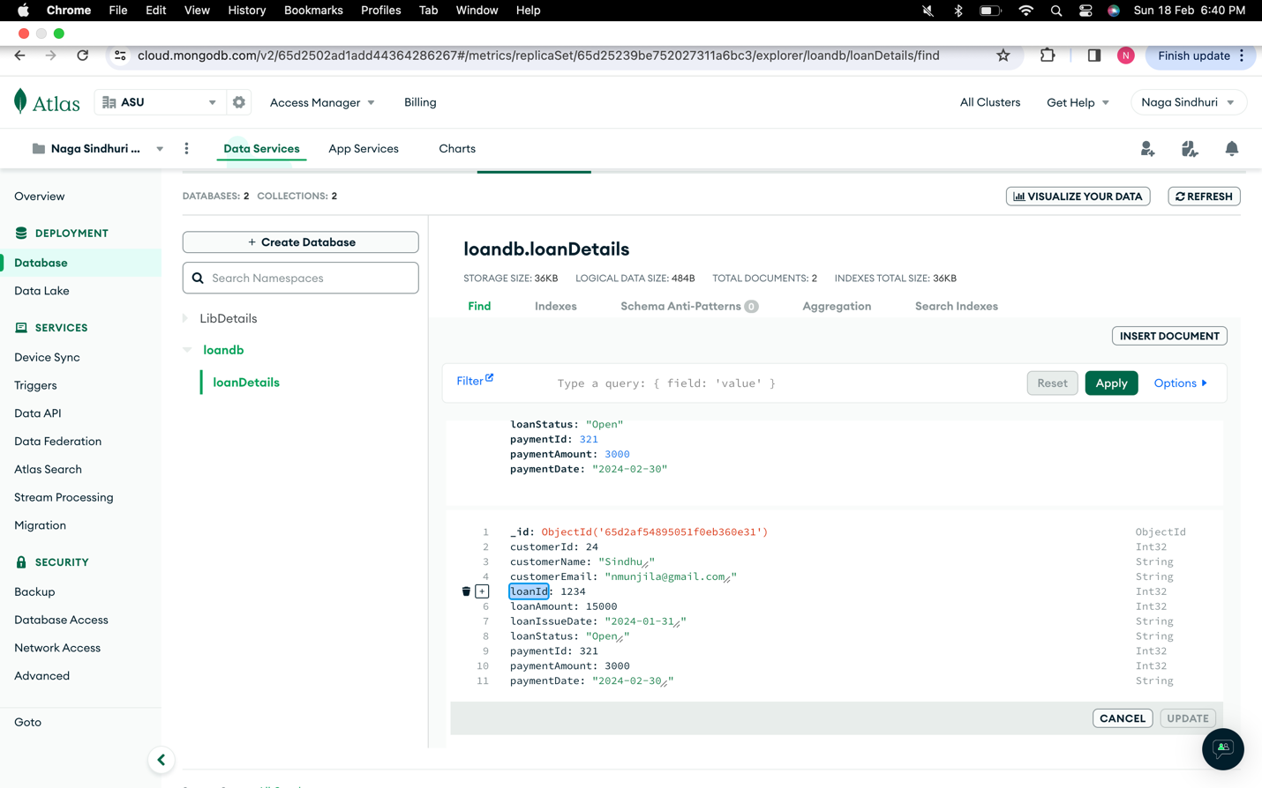

Update: Now, updating the loan Id 1234 by customerName to Cindy.

Postman:

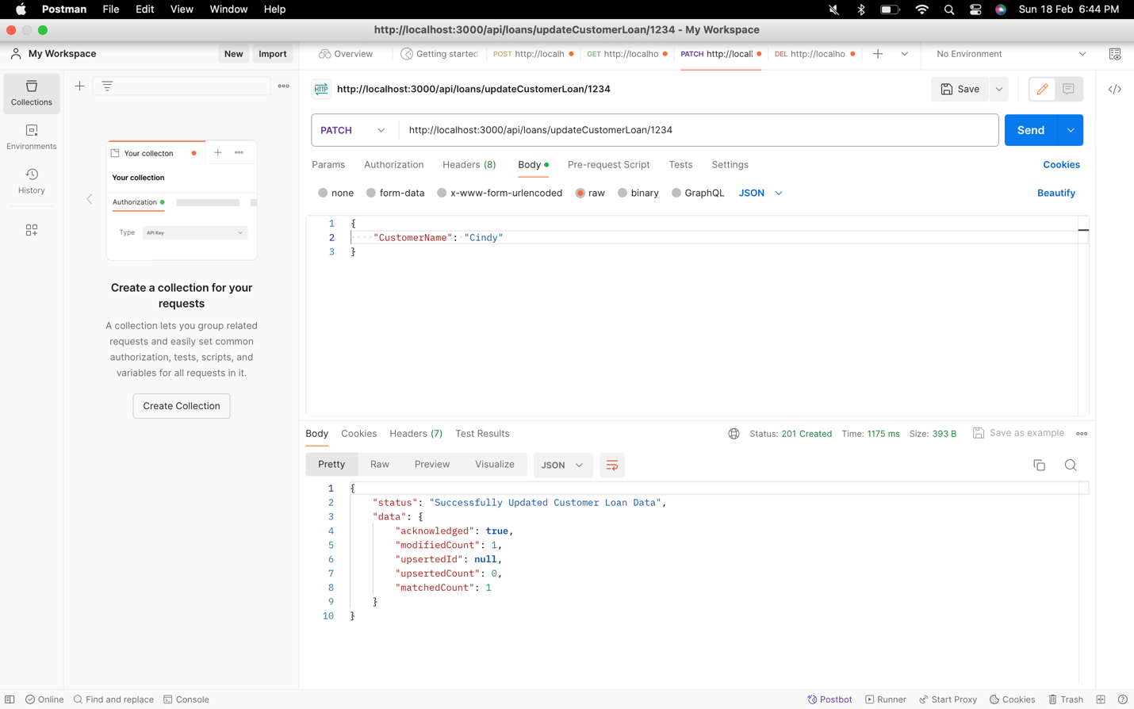

Terminal:

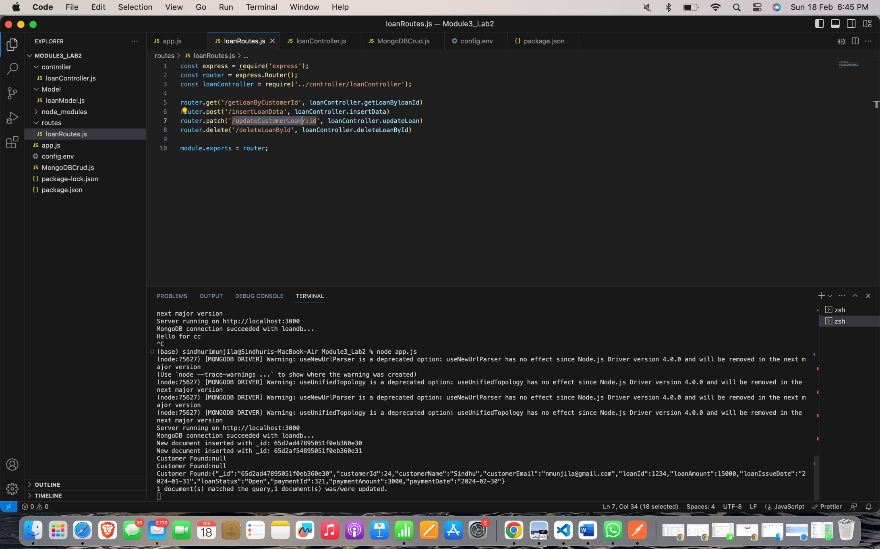

Atlas:

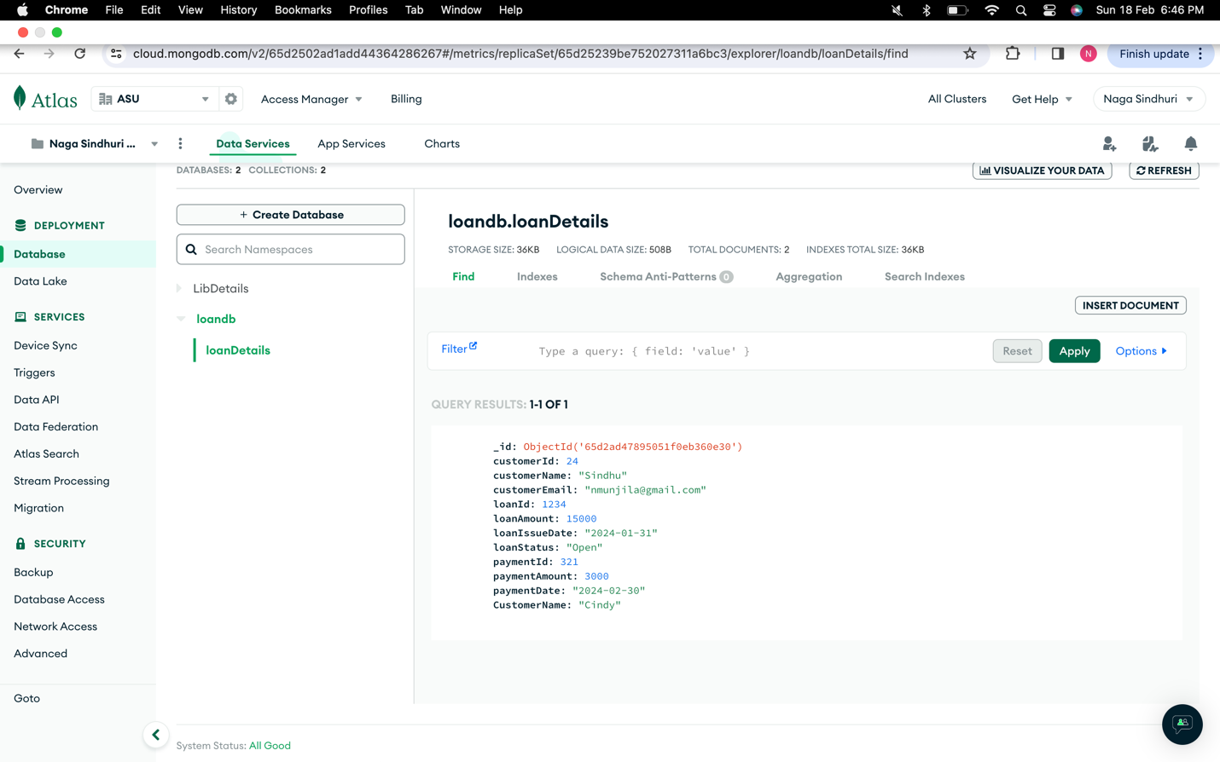

Delete: Deleting the customer base on loanId.

For this operation, I’m inserting a new document.

I have added new customer with Id 25, then deleting it.

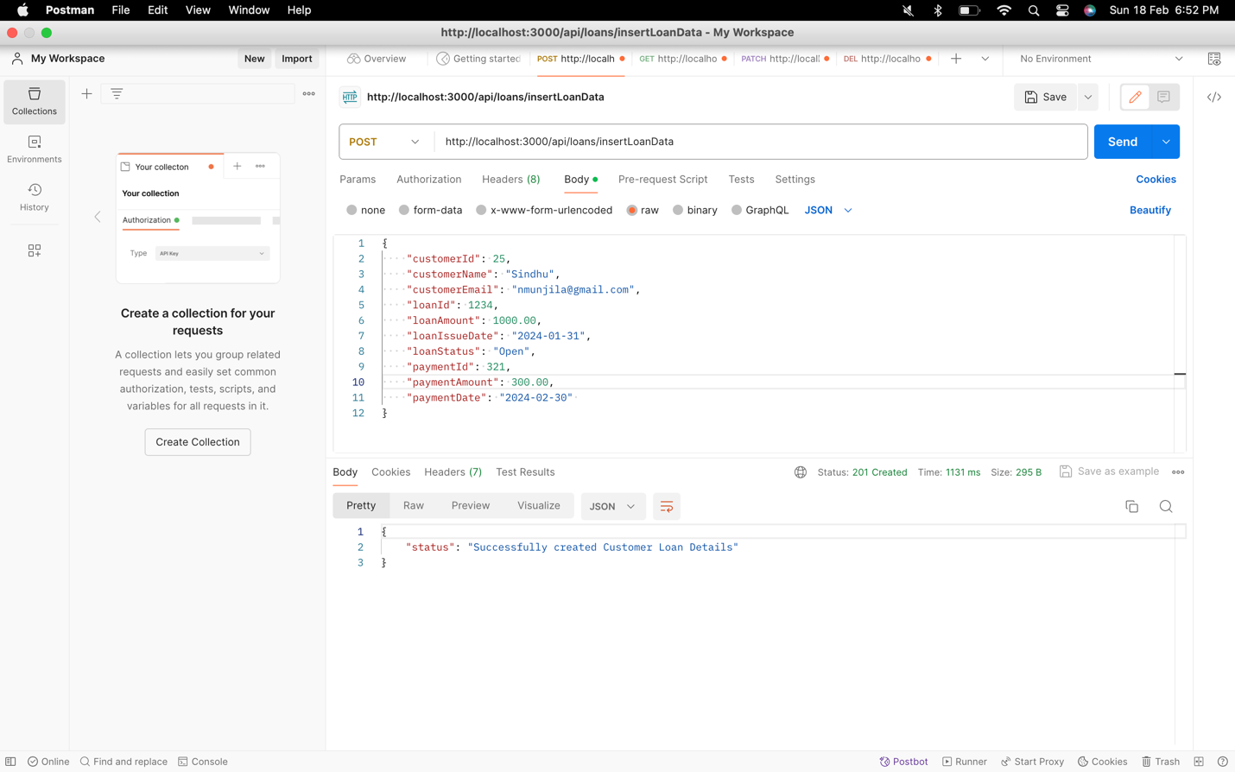

Atlas:

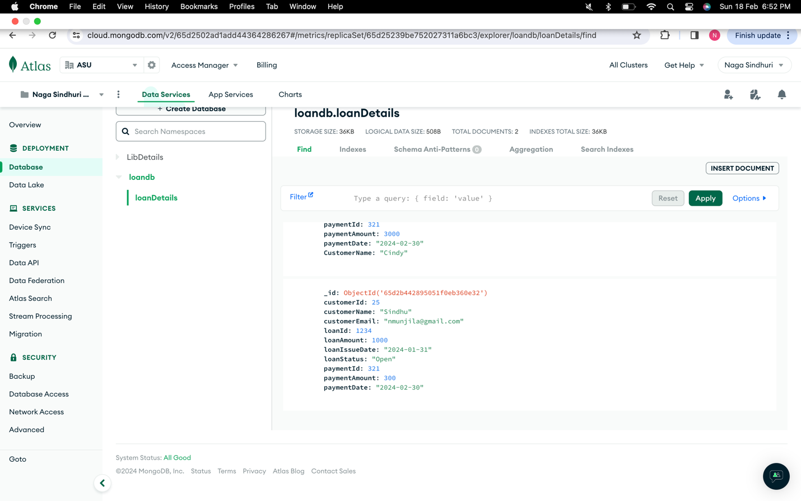

Now, delete this customer 25 using delete operation with help of LoanId.

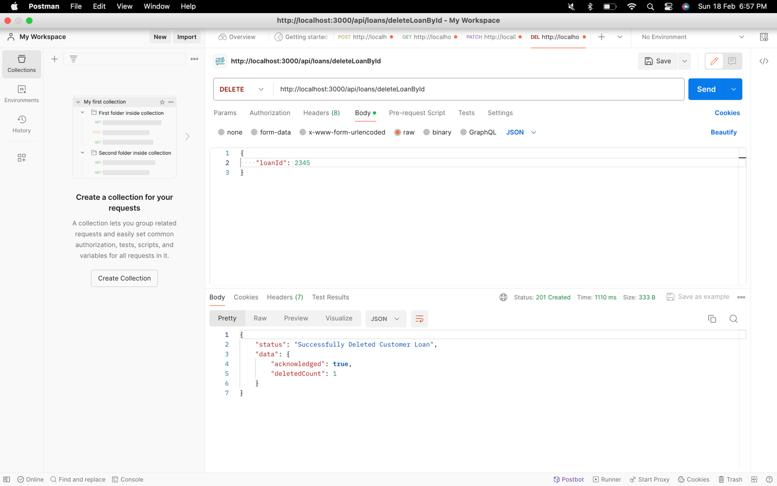

Terminal:

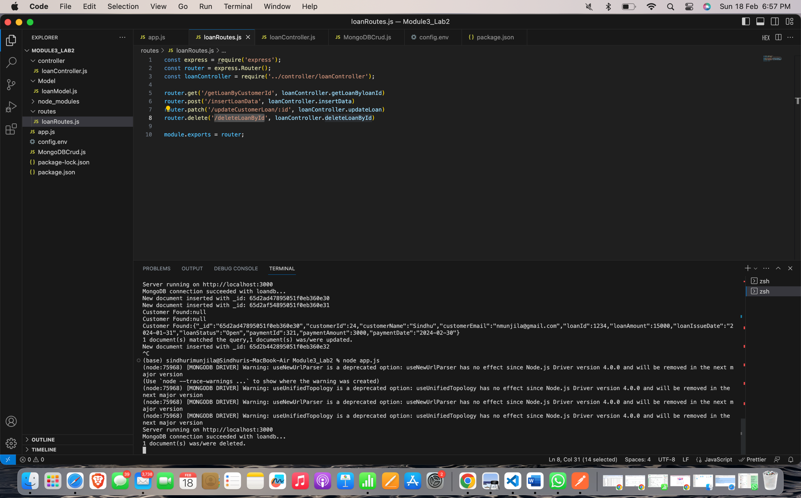

Atlas:

